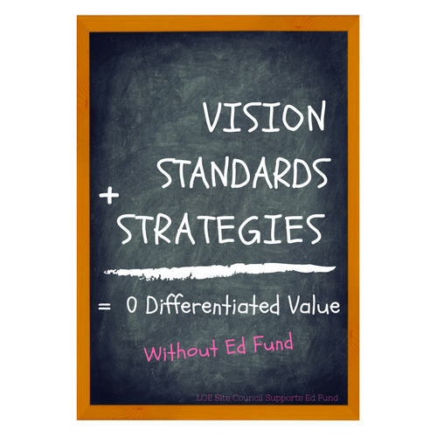

Dear Parent(s):

It is true -- without Ed Fund’s financial support the work we do to ensure our school’s vision, maintain high academic standards and implement strategic interventions to account for success for all students would be highly compromised. As the governing board of Live Oak Elementary School, School Site Council (SSC) fully supports Ed Fund and its initiatives.

SSC is responsible for analyzing the academic performance of all student groups and to consider the effectiveness of key elements of Live Oak’s instructional program. One of our responsibilities is to adopt school goals as seen in the Single Plan of Student Achievement (SPSA), related actions and expenditures to raise the academic performance of all students and support those not yet meeting state standards. Ed Fund directly funded 51% of the total expenditures of the action items put forth in the SPSA, 2016 - 2017. That’s a significant value add to supplement certificated and classified salaries, books, supplies and professional training and consulting. This is in addition to already supporting technology, field trips and activities.

Every year state and local budget allocations become leaner and leaner. The financial support of parents, allows Live Oak to differentiate itself as a standard bearer in the Valley for not only its academic achievements, but its daily strategic intention for our students to thrive as members of their community and good citizens.

School Site Council, is proud to support Ed Fund and hope you will do the same in making a financial donation. If you would like to learn more about your School Site Council and our accountabilities, please visit http://www.loes.schoolloop.com/schoolsitecouncil. To make a donation visit http://www.loes.schoolloop.com/educationfund.

Sincerely,

Live Oak Elementary School Site Council

